Getting Started with TDD
Implementing the Class Diagram as Code

Introduction 1
Creating the First Test 1
Creating a Simple Class 3
THIS IS REALLY IMPORTANT 14
So, Where Next? 14
Creating the Properties 14
Creating Methods 17
The Test Plan Pro Forma 22
Creating a Simple Presentation Layer 31
Creating Controls 34
Linking the Web Site to the Class Library 36
Adding the Presentation Layer Code 38

Introduction
Shortly as a team you will be working collaboratively on GitHub. I know you are eager to get on but before you start GitHub I want you to work through some individual examples such that you know what you are doing when you do this for real.
One issue with working collaboratively is you have very real potential to mess up another person’s work if you are not sure what you are doing.
Treat these first tasks as a dry run. I also want you to try out something called pair programming which is intended to assist you as you write your code.
Pair Programming is again drawn from industry and the idea is pretty simple. One person sits at the computer and writes some code whilst a second programmer looks over the first person’s shoulder and helps them if they get stuck. After say thirty minutes the two people swap over and change roles.

Creating the First Test
So you have a Class Diagram!
Good for you!
The next step is to turn that diagram into some classes and ultimately some code that does the job you want.
The first rule of development is to do the simple stuff first.
Writing a program is like building a house.
You simply cannot put the roof on the house before you have the foundations and walls in place.
Developing a system is often made difficult by trying to perform the final tasks first!
Do the stuff you understand first – the simple stuff, the simpler the better.
Once you have achieved that, the rest of the development will make more sense.
In this guide we will look at some approaches to programming that break the problem down into small digestible chunks or bricks.
Once we have enough bricks created we will be in the position to assemble them into something looking like a system.
The first clue as to what the bricks look like is the class diagram. Here is the generic class diagram provided for you.
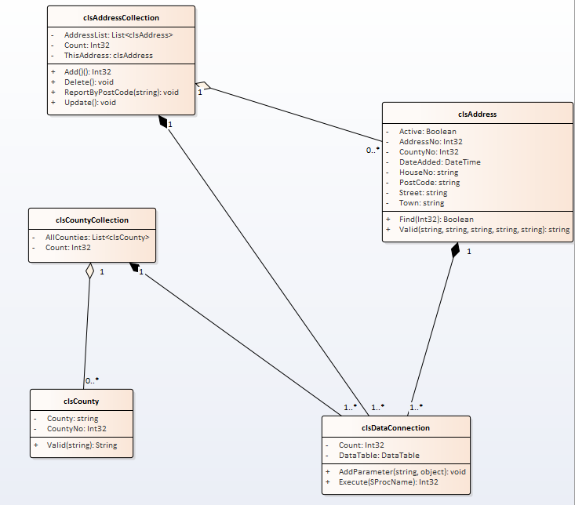
You have
- Individual classes
- Attributes
- Operations
- Relationships indicating
  - Aggregation
  - Composition
  - Collections
There is a lot of development required here.

Creating a Simple Class
So, as stated above let’s start with the simplest thing that we can possible do.
Let’s create a test to ensure that an instance of a class may be created.
On the module website there is a configured three tier project against which you may complete this section of the work individually, i.e. not collaboratively using Git.
Once you have downloaded and extracted the zip file Address Book Starter.zip you should see the following files...
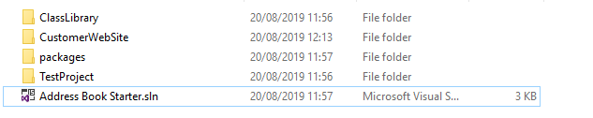
Double click the sln file to open Visual Studio. After a while you should see something like the following screen...
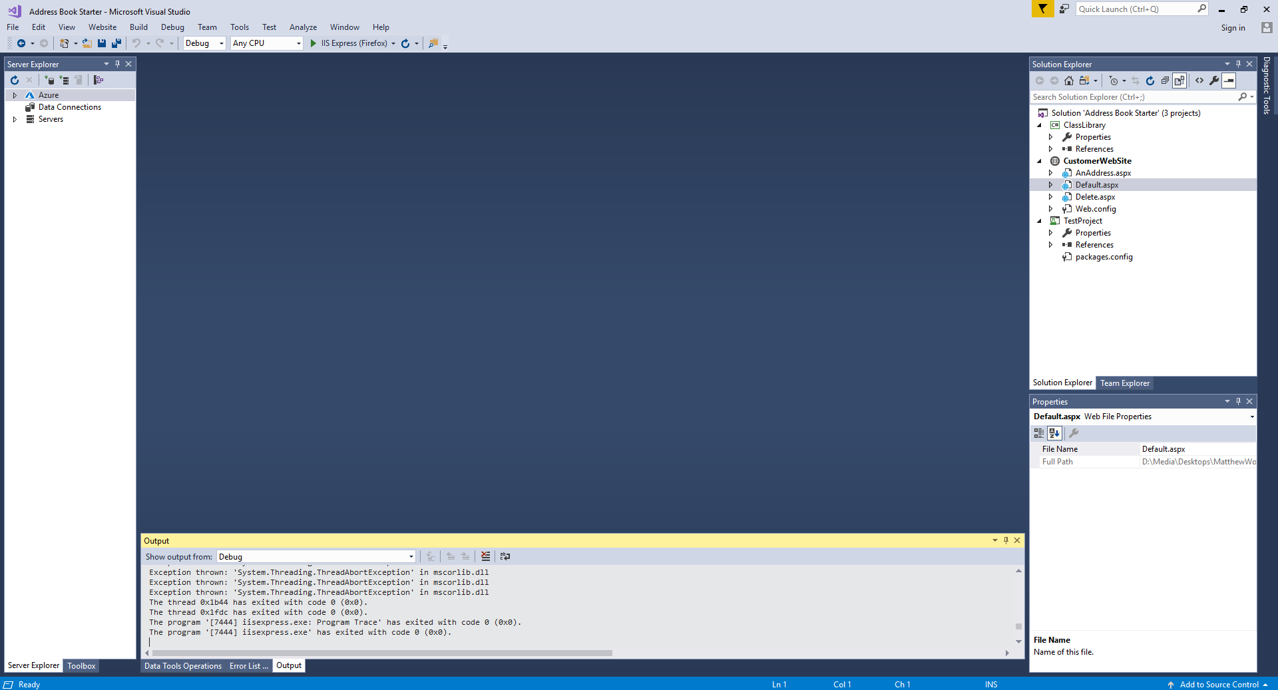
If you take a look on the right you will see the different sections of the solution have already been configured for you...
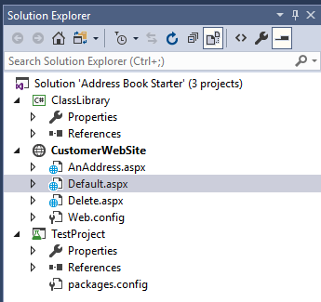
The class library is where we will store all classes needed for the project, the customer web site contains web forms for user interaction and the test project is where our test classes will be stored.
The next step is to decide on which class we are going to implement...
We could in theory pick any of them but as I said above it is best to start with something nice and simple.
So we will create the class clsCounty
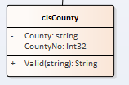
It has two attributes and one operation.
To create the test class for this class we need to create a test class called tstCounty
To create the test, right click on the test project select Add – New Item…
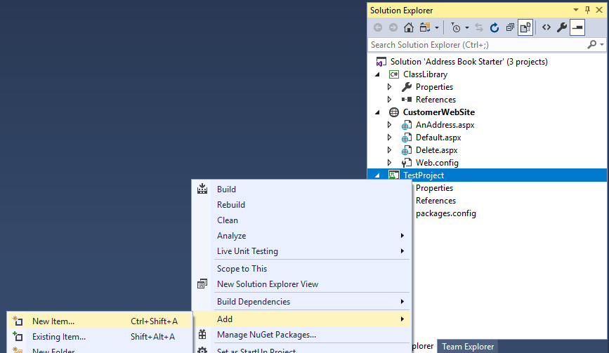
From the list of options, select basic unit test and set the name of the test class to tstCounty.
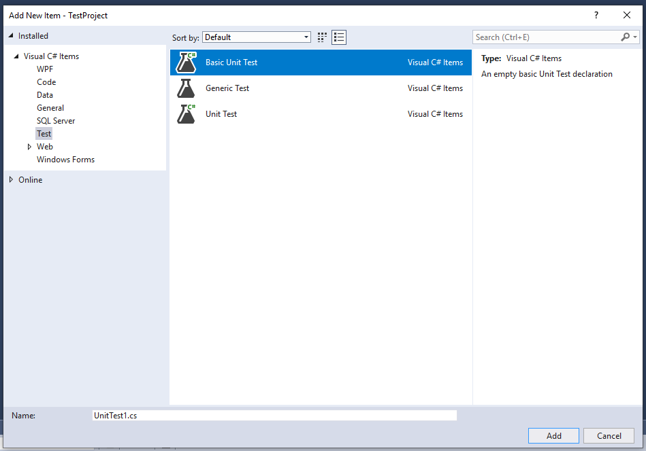
The idea is that for each class that we create from the class diagram we will have a corresponding test-class to contain the testing for that class.
So tstCounty contains the testing for clsCounty!
You should see something like this…
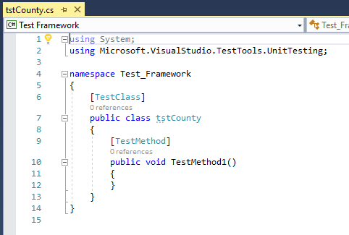
We will now create the first test.
There are three rules for TDD
- Create a test that fails
- Fix the test (in some simplistic way)
- Re-factor the code to make it work “properly”
The first test we will create is to see if we can make a valid instance of the class clsCounty.
The first test method should look something like this…
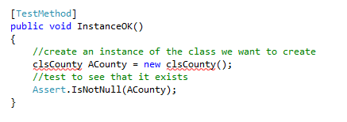
Things to note at this stage
- The fact that the class hasn’t been created is irrelevant
- The red underlining is not important
- It is a good idea to name your tests in a way that makes sense. Doing this ensures that when things go wrong (and they will) you have some idea as to where the problem is.
The next step is to run the test and see it fail.
From the main menu select, Test – Run – All Tests...
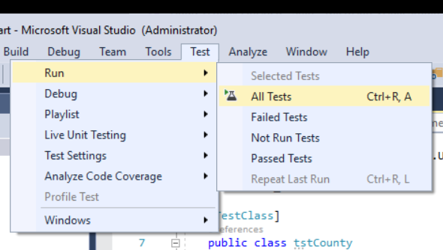
In this case you should (obviously) get a compilation error due to the red underlining…
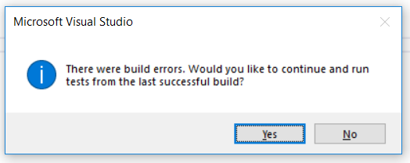
(Press No!)
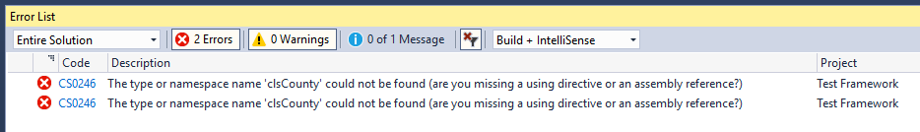
OK – the next step is to fix the problem.
We need to make sure that the class actually exists in our class library.
Hold the mouse over the class name with the red underlining and you will see the following message pop up…
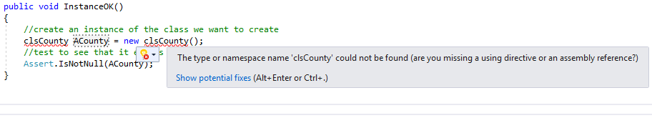
Click on “show potential fixes” you should see the following options
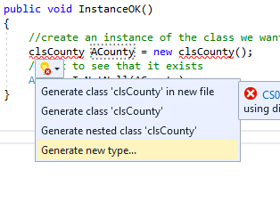
From this menu select Generate new type.
You should see the following window…
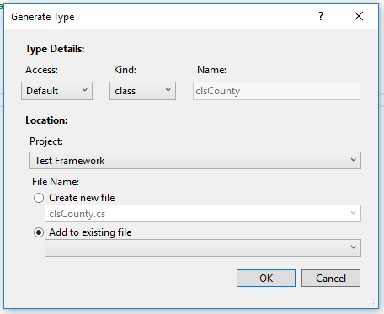
You really need to pay attention to the settings on this window as getting it wrong will result in your class being created in the wrong location.
Change project location to your class library, not the test framework and make sure that “Create new file” is selected like so…
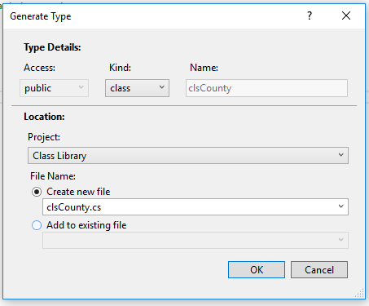
Then press OK.
You will know that you have done this correctly because your class file will be visible in your class library…
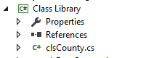
The red underlining should also disappear…
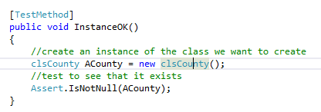
Run your tests and you should see the test pass…
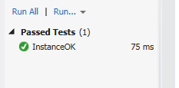

THIS IS REALLY IMPORTANT
As a student you are going to be under a lot of pressure to complete the work for this module.
The temptation will be to press on as fast as humanly possible in spite of any errors in the hope that errors go away.
So, the important point....
You should never have more than one failed test in the list of tests.
If you have a test that has turned red, stop everything else that you are currently doing and do not continue until you have fixed the problem and turned the test from red to green.

So, Where Next?
You have just dug the first post hole in building the foundations of your house. Without that first hole in the ground nothing else will happen in the construction process.
We could now go in several different directions with the development of the system.
We could concentrate on this class and get that finished i.e. dig the hole deeper until it is done. Or we could make a start on all of the other classes, i.e. make a start on all of the other holes for the foundation.
For this example we will concentrate on making this hole deeper so that we end up with a (mostly) completed class file.

Creating the Properties
Looking at the class diagram we may as well go for the two properties next…
So let’s write the test immediately following the test we have already created.
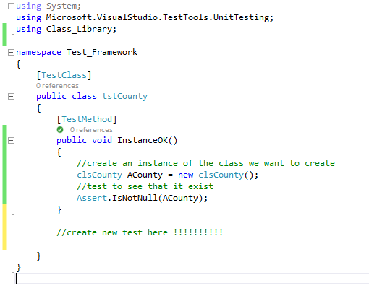
Here is the next test…
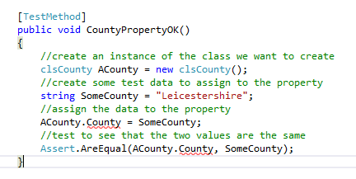
From the red underlining we should be able to see that there is going to be a problem.
Try running the test to confirm that it doesn’t compile…
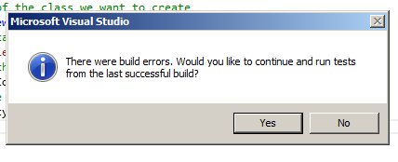
So the next step is to create the County property.
As before hold the mouse over the red underlining and select show potential fixes…
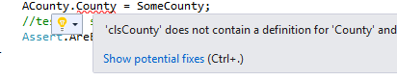
Followed by the option to generate the property…
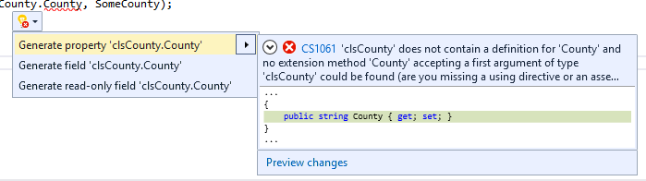
This should result in your tests passing.
Create a similar test for the CountyNo property like so…
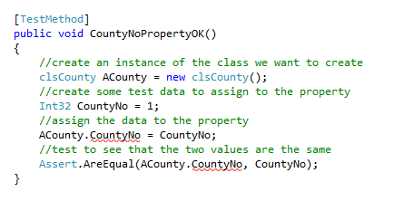
Now follow the same procedure. Run the test watch it fail and then put in the fix.
You should see all tests pass.
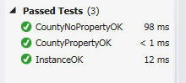
Again this may not seem like much but we are slightly closer to the finished system than we were a few tests ago.
The other important thing is that in writing the tests we can be confident that the code is correct.
Ideally the code for the system should grow gradually out of the tests that we write.

Creating Methods
So what’s left?
We have one operation to think about which will be needed to validate any new county values we want to enter into the system.
The method will accept a single parameter representing a new county to be validated. The method will return a string reporting the nature of the error.
We could use the method like this…
//create a new instance of the county class
clsCounty ACounty = new clsCounty();
//copy the user input from the interface
string NewCounty = txtCounty.Text;
//if the data validates
if (clsCounty.Valid(NewCounty) == “”)
{
//do something with the data
}
else
{
//display an error message
}
So, the first step is to write is a test method that checks to see that the method actually exists.
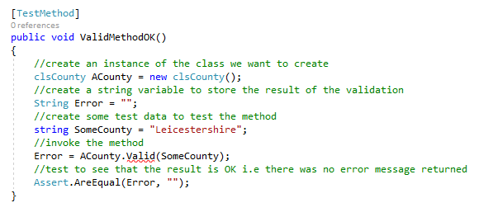
In this case we are sending the method some valid data so we would expect the result of the validation to be true, i.e. a blank string is returned.
As before, because we have yet to write the method so the test will fail due to the red underlining…
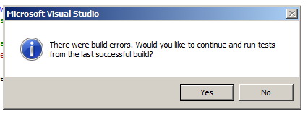
To fix this we need to create the method stub.
The procedure is as above.
Hold the mouse over the re underlining…
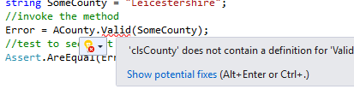
Select “Show potential fixes”…
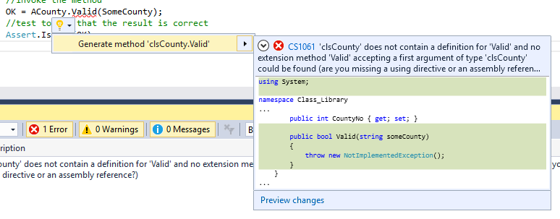
Generate the method.
Run the test again and you should see it fail! (Now what!?!)
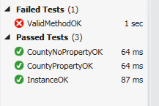
We now have a red failing test, remember we must not ignore this and move on we have to turn that test from red to green!
The problem is that for the method to work correctly we need to write some actual code.
If we open the class file clsCounty...
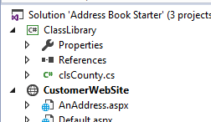
Click here

Taking a look at the auto generated code, we see the following…
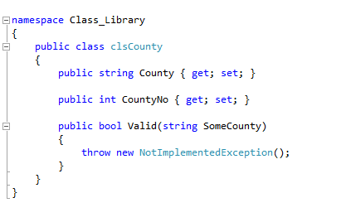
The code stating throw new NotImplementedException(); is resulting in the program always giving us an error.
First we need to get rid of the line as we don’t need it.
Next we need to add some of our own code to implement a partial fix to make the test work.
What we are checking for is if a non blank value has been supplied to the function via the parameter we want the function to return an error message. If the name of the county is blank then we need to return a blank string.
The following code should do the trick…
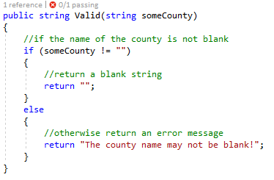
Run the test and it should pass.
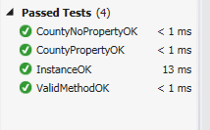
We are now a bit further on in building our system with a good level of confidence that we are doing it right.
The next step is to spend a bit of time creating a more structured approach to the test data.
To do this we will use the test plan pro forma.

The Test Plan Pro Forma

Description of Item to Be Tested:

Required Field Y / N

Test Type | Test Data | Expected Result | Actual Result
Extreme Min
Min -1
Min (Boundary)
Min +1
Max -1
Max (Boundary)
Max +1
Mid
Extreme Max
Invalid data type
Other tests

Additional Notes / Instructions:

In order to test the parameter for the county validation we will need to think about appropriate tests so that we know it is working correctly.
We will also need to do this with an eye to the final database design. We need to start thinking about two things...
- Is the field a required field? (Can it be left blank or not?)
- What is the maximum number of characters for this field?
In this case County field may not be empty and we will decide now that the name of the county has a maximum length of 50 characters.
The test data might look something like this…

Description of Item to Be Tested:

SomeCounty parameter of the Valid method of clsCounty.

Required Field Y

Test Type | Test Data | Expected Result | Actual Result
Extreme Min | NA | NA
Min -1 | Blank string | Fail
Min (Boundary) | One character ‘a’ | Pass
Min +1 | Two characters ‘aa’ | Pass
Max -1 | 49 characters  0123456789012345678901234567890123456789012345678 | Pass
Max (Boundary) | 50 characters  01234567890123456789012345678901234567890123456789 | Pass
Max +1 | 51 characters  012345678901234567890123456789012345678901234567890 | Fail
Mid | 25 characters  0123456789012345678901234 | Pass
Extreme Max | 500 characters  01234567890123456789012345678901234567890123456789  01234567890123456789012345678901234567890123456789  01234567890123456789012345678901234567890123456789  01234567890123456789012345678901234567890123456789  01234567890123456789012345678901234567890123456789  01234567890123456789012345678901234567890123456789  01234567890123456789012345678901234567890123456789  01234567890123456789012345678901234567890123456789  01234567890123456789012345678901234567890123456789  01234567890123456789012345678901234567890123456789 | Fail
Invalid data type | NA
Other tests | NA

Additional Notes / Instructions:

We now need to write the test methods to apply the above test plan.
So the tests we need to write are as follows…
Min -1 | Blank string | Fail

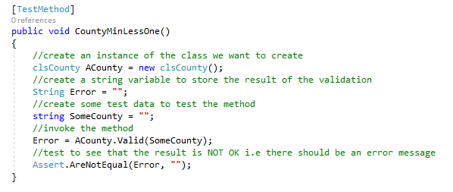
Run all tests to make sure nothing is turning red!
With the code we created for the previous test we get lucky as it also addresses this new test too.

Min (Boundary) | One character ‘a’ | Pass

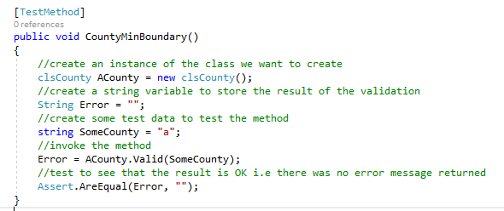
Run all tests to make sure nothing is turning red!
Same with this test – our existing code should address it too.
Min +1 | Two characters ‘aa’ | Pass

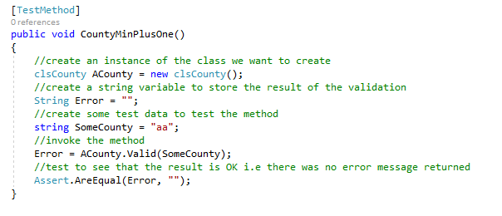
Run all tests to make sure nothing is turning red!
Max -1 | 49 characters  0123456789012345678901234567890123456789012345678 | Pass
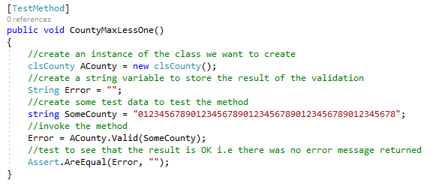
Run all tests to make sure nothing is turning red!
This one should be OK too.
Max (Boundary) | 50 characters  01234567890123456789012345678901234567890123456789 | Pass

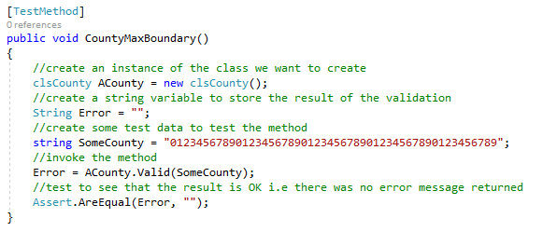
Run all tests to make sure nothing is turning red!

And this one!
Max +1 | 51 characters  012345678901234567890123456789012345678901234567890 | Fail

This test is not accounted for by our existing code – it should give the wrong result.
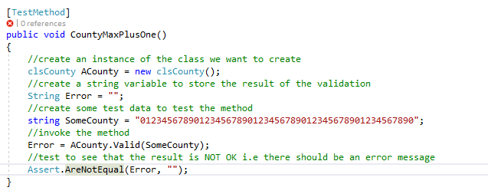
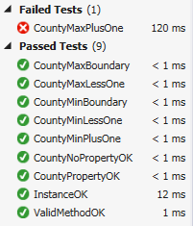
So we need to modify the validation code to take into account for data longer than 50 characters.
Let’s modify the validation code in clsCounty so that it looks like this…
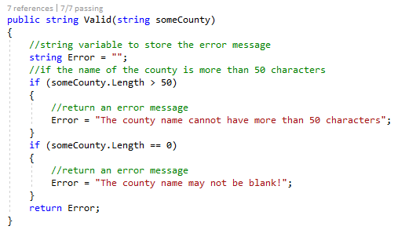
Run the tests – do they all pass?
Yes they do.
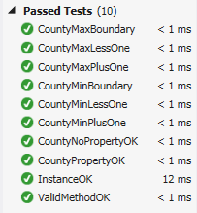
Mid | 25 characters  0123456789012345678901234 | Pass

What about the mid range test?
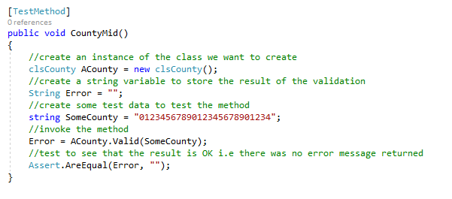
All fine.
What about the extreme max test?

Extreme Max | 500 characters  01234567890123456789012345678901234567890123456789  01234567890123456789012345678901234567890123456789  01234567890123456789012345678901234567890123456789  01234567890123456789012345678901234567890123456789  01234567890123456789012345678901234567890123456789  01234567890123456789012345678901234567890123456789  01234567890123456789012345678901234567890123456789  01234567890123456789012345678901234567890123456789  01234567890123456789012345678901234567890123456789  01234567890123456789012345678901234567890123456789 | Fail

Well…
Before we create this test we need to think about how we are creating our test data. There are no hard and fast rules on how we do this. One thing we want to do is make it as easy as possible.
We could, in the test data above, type a string of 500 characters. Or we could make the system work on our behalf like so…
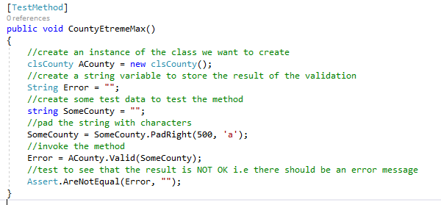
PadRight is a built in method that allows us to pad out an existing string with a set number of a specific character.
Having created the automated tests for the class we can be pretty sure that the component we have built so far is functioning correctly. Also as the system grows and we run our tests we get a constant check to make sure that we don’t break our system further down the line.
Now that you have created the County attribute/property try creating the CountyNo attribute. The procedure is very similar but you need to think about what the test data might look like for an integer data type.

Creating a Simple Presentation Layer
Now that we have created our testing and class code it might be a nice idea to add on an interface to see if the code works as planned.
In Visual Studio right click on the CustomerWebSite and set it as the start up project like so…
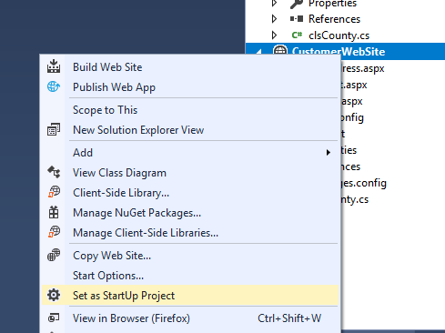
Next, right click on the web site again and select add new item…
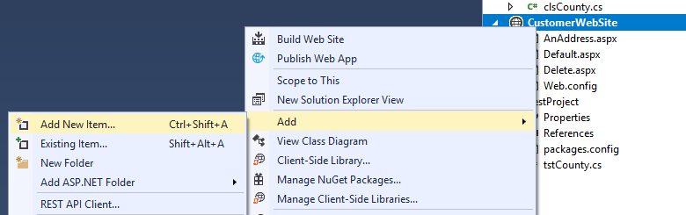
Select web form and set the name to ACounty.aspx…
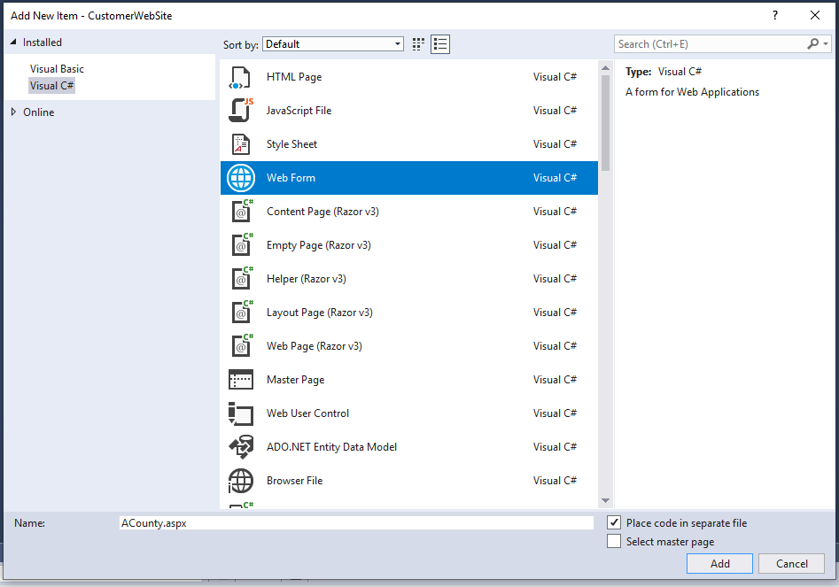
Press Add and you should see the following page created…
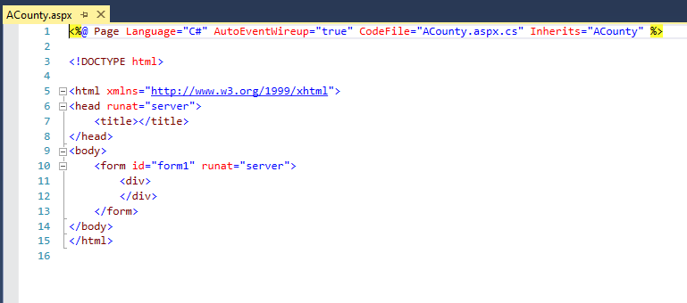
To switch over to the visual editor press Design…
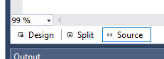

Creating Controls
To create controls in this view you need to drag them over from the toolbox on the left of the interface…
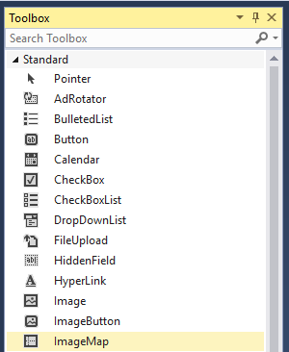
If it isn’t visible you may need to select the correct tab at the bottom of the window…
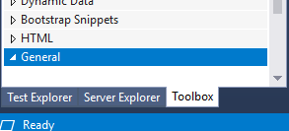
Drag the label control in the toolbox…
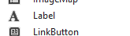
Over to the blank web form, the control should be created for you…
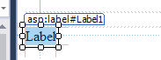
Now access the properties for the new control in the bottom right of the interface…
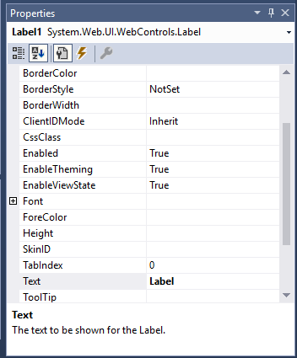
Find the property for Text and change it to “County Name”
Next set the ID for the control to lblCounty
Notice the naming convention we are going to use here…
lbl indicates to the programmer that the control is a label
County indicates what the control is for
Next set up a text box using the same procedure such that the interface looks something like this…
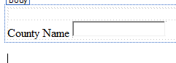
Set the ID if the text box to txtCounty
Beneath these controls add a second label called lblError with the text property empty like so…
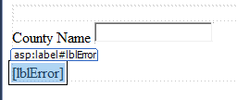
Finally add a button called OK like so…
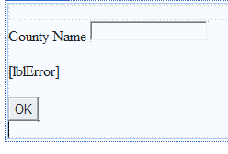
Set the ID to the button to btnOK and the text to “OK”

Linking the Web Site to the Class Library
Having created a whole load of code in our class library we certainly do not want to write that code again.
To link the middle layer code to the interface we need to add a reference to the web site so that it knows to use it.
Right click on the web site and select Add - Reference…
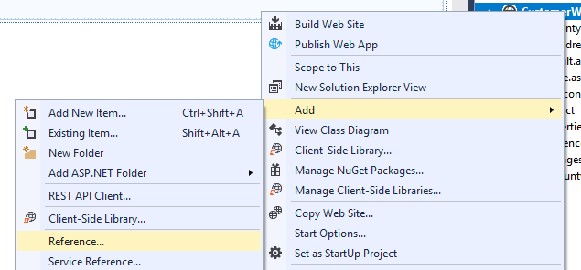
Under solution make sure there is a tick against the class library…
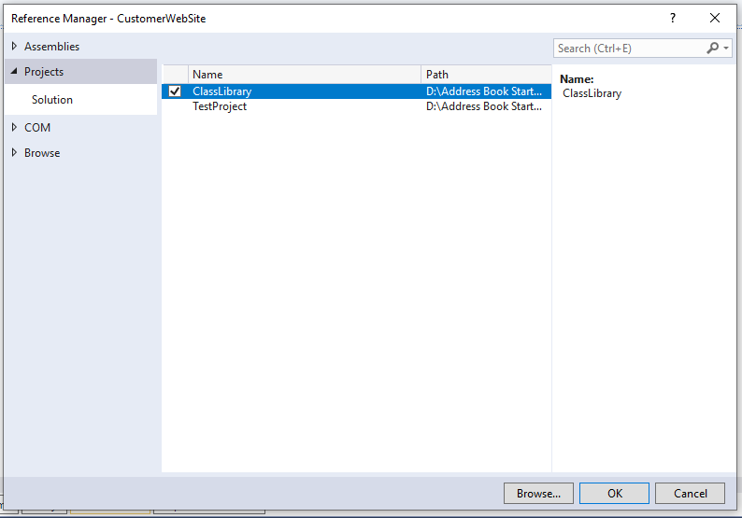
This will tell the web site to make use of the code in the class library.

Adding the Presentation Layer Code
Next double click on the OK button to access the event handler for the click event.
You should see the following…
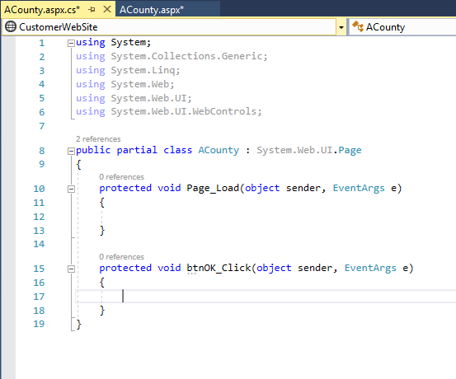
First try the following code…
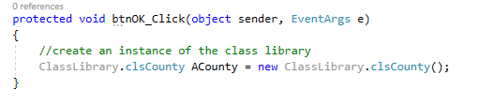
Note how we have to enter the name of the class library every time we want to create a new object. This is likely to become tedious.
To stop this, add a Using at the top of the code like so…
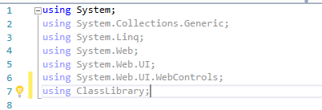
You may now modify the code for the event handler like so…
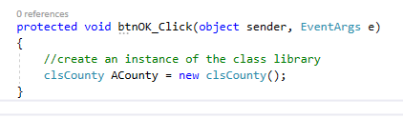
Try out the following section of code…
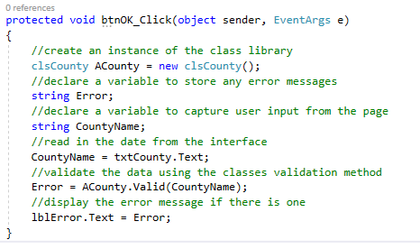
Before we run the program right click on the new web form and set it as the start up page…
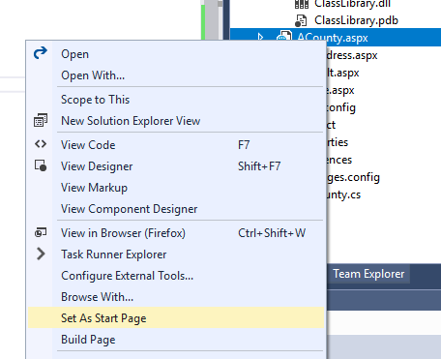
Now press F5 or the green play button on the menu 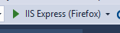.
Your page should now be displayed…
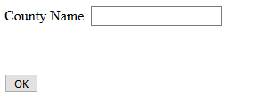
Using the test data from your test plan see if the errors are correct for when you enter bad and good data like so…
